Bottom footer add:
Licensed • Insured • 100% Satisfaction Guarantee • Employee/Community Based Company

Weather Forecast - along with scheduling or on the front page - UVI, Wind, Precipitation, Humidity, Visibility, Pressure, Air Quality. Make it a clickable icon next to the login/logout button on the left side for desktop version

Meet the team:
add:
Christina Nyugen - QC

Bobby Reynoso - Field Technician

Sandy Viramontes - Account Representative
Brianna Miyake - Operations/Customer Service
Remove:
Maya Velasquez
Update:
Elijah Noble - IT tech, etc

CA seal added to the bottom of pages/footer next to the anaheim seal

Update Mission statement in the about us section:
“At No More Mosquitoes, we provide premium insecticide application services designed for those who expect the highest standard of outdoor comfort. Our mission is to refine mosquito and other insects that overrun communal areas. Through advanced treatments, precision application, safe & effective insecticides, and exceptional care we guarantee 100% satisfaction in all our treatments. As we commit in protecting the health and comfort of our community, you will undoubtedly trust and enjoy your mosquito-free environment.”
Replacing the
How One Backyard Evening Sparked a Mission to Protect Yours
A California Employee/Community Based Company
We transformed a frustrating family gathering into a full-service mosquito and pest program trusted by hundreds of Orange County homeowners.
Meet the Team
Section.
FAQ Section update

1. What services does No More Mosquitoes provide?
We specialize in professional mosquito control and general insect management for residential and commercial properties using safe, effective, and targeted treatments.

2. What areas do you service?
We provide service throughout your local region. Contact us to confirm availability in your specific area.

3. How do your mosquito treatments work?
We apply advanced insecticides to key mosquito resting and breeding areas, targeting them at multiple life stages for maximum effectiveness.

4. Are your treatments safe for families and pets?
Yes. We use products that are EPA-approved and applied with precision. Once dry, treated areas are safe for normal activity.

5. How long does a treatment take?
Most treatments take 15–30 minutes depending on property size.

6. How quickly will I see results?
You’ll typically notice a significant reduction in mosquito activity within 24–48 hours.

7. Do I need to be home during the service?
No. As long as we have access to the treatment areas, you do not need to be present. Video s

8. What makes No More Mosquitoes different?
We focus on premium service, precision application for guaranteed results—not just spraying, but strategic insect control.

9. Do you offer free estimates?
Yes, we provide free consultations and quotes.

10. Do you guarantee your service?
Yes. We stand behind our work with a satisfaction guarantee.

Mosquito-Specific Questions

11. How often should I get mosquito treatments?
Typically every 3–4 weeks for consistent protection during peak seasons.

12. Do treatments eliminate all mosquitoes?
While no service can guarantee 100% elimination, we dramatically reduce mosquito populations to near-zero levels.

13. What attracts mosquitoes to my yard?
Standing water, shade, dense vegetation, and humidity all contribute to mosquito activity.

14. Can you treat standing water?
Yes. We apply larvicides to prevent mosquitoes from breeding in water sources. Our mosquito fish program is also effective on mosquito larvae.

15. Will rain affect the treatment?
Once dry, treatments are designed to withstand normal weather conditions, including rain.

16. Do you offer one-time treatments?
Yes, ideal for events or immediate relief.

17. Do you offer seasonal plans?
Yes, we offer recurring service plans for ongoing protection.

18. Are your treatments effective against mosquito-borne diseases?
Our services significantly reduce mosquito populations, lowering the risk of exposure.

19. What time of day do you treat?
We typically treat during times when mosquitoes are most active, often early morning or evening.

20. Can you help with severe infestations?
Yes, we can implement more aggressive treatment plans for high-activity areas.

Other Pest Control Questions

21. Do you treat insects other than mosquitoes?
Yes. We also handle a range of common outdoor pests.

22. What types of insects do you control?
Most outdoor insects. This includes flies, gnats, ants, cockroaches, crickets other many other nuisance insects.

23. Do you offer indoor pest control?
Our primary focus is outdoor insect control, but ask about our referral program

24. Are your treatments environmentally friendly?
We prioritize responsible application methods and products that minimize environmental impact.

25. Will your service harm beneficial insects?
We apply treatments strategically to target pests while minimizing impact on beneficial species.

Preparation & Aftercare

26. How should I prepare for my treatment?
We recommend clearing clutter and limiting pet access to yard areas.

27. Do I need to cover outdoor furniture?
Not typically required, but you may do so if preferred.

28. When can I return outside after treatment?
Once the product has dried, usually within 30–60 minutes.

29. Should I water my yard after treatment?
Avoid watering immediately after service unless instructed otherwise.

30. How can I improve results between treatments?
Eliminate standing water and maintain yard cleanliness.

Pricing & Plans

31. How much does your service cost?
Pricing depends on property size and service frequency. Contact us for a custom quote.

32. Do you offer subscription plans?
Yes, we offer recurring service packages for ongoing protection.

33. Are there contracts required?
no-contract services, we offer flexible options

34. Do you offer discounts?
Ask about seasonal promotions or bundled services.

35. What payment methods do you accept?
We accept most major payment methods for your convenience.

Scheduling & Service

36. How do I schedule a service?
You can schedule directly through our website: nomoremosquitoes.us or contact us.

37. How soon can I get service?
We often offer fast scheduling, sometimes same or next day depending on availability.

38. Can I reschedule my appointment?
Yes, simply contact us in advance.

39. What happens if it rains on my service day?
We will reschedule if conditions are not suitable for effective treatment.

40. Do you offer emergency services?
Yes, for urgent mosquito problems or special events.

Business & Trust

41. Are you licensed and insured?
Yes, we operate in compliance with all local and state regulations.

42. How experienced is your team?
Our technicians are trained in advanced application techniques and pest control strategies.

43. What products do you use?
We use professional-grade, industry-approved insecticides.

44. Is your service suitable for commercial properties?
Yes, we service businesses, event spaces, and large properties.

45. Can you handle large properties?
Absolutely. We scale our services based on property size and needs.

Results & Expectations

46. What level of mosquito reduction should I expect?
Most clients experience a dramatic decrease, often 80–95% reduction.

47. Will mosquitoes come back?
Without maintenance, mosquitoes can return.

48. Do you provide ongoing monitoring?
Yes, with recurring services we continuously manage and adjust treatments.

49. What if I’m not satisfied?
There’s a reason they’re called pests. Don’t worry we will re-treat and address the issue as part of our satisfaction guarantee.

50. How do I get started?
Visit nomoremosquitoes.us or contact us directly to schedule your first service.
Add images for add ons
Mosquito dunks: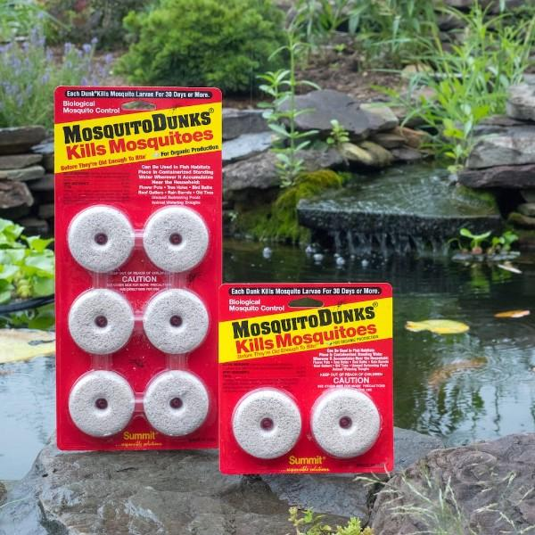
Flytrap service:

Gutter Cleaning:
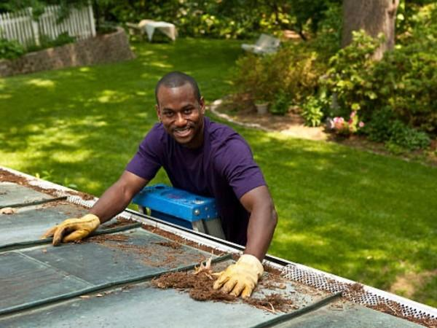
Spider web removal service
